Farm Yield Optimization:

Create farmers table
CREATE TABLE farmers (
farmer_id INT PRIMARY KEY,
first_name VARCHAR(50),
last_name VARCHAR(50),
email VARCHAR(100),
hire_date DATE
);
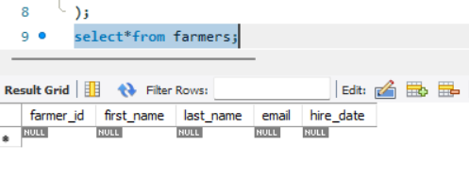

Create plots table:

CREATE TABLE plots (
plot_id INT PRIMARY KEY,
plot_name VARCHAR(100),
farmer_id INT,
crop_type VARCHAR(50),
soil_type VARCHAR(50),
FOREIGN KEY (farmer_id) REFERENCES farmers(farmer_id)
);

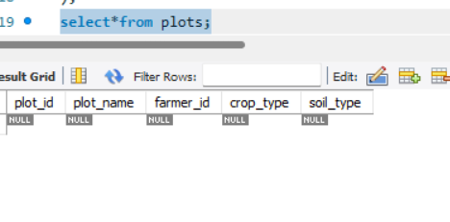

Create yields table:
CREATE TABLE yields (
yield_id INT PRIMARY KEY,
plot_id INT,
harvest_date DATE,
yield_kg DECIMAL(10, 2),
weather_condition VARCHAR(50),
FOREIGN KEY (plot_id) REFERENCES plots(plot_id)
);

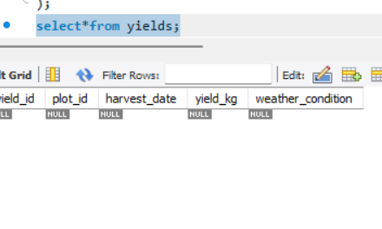

. Create the irrigation_logs Table:
CREATE TABLE irrigation_logs (
log_id INT PRIMARY KEY,
plot_id INT,
irrigation_date DATE,
water_amount_liters DECIMAL(10, 2),
FOREIGN KEY (plot_id) REFERENCES plots(plot_id)
);
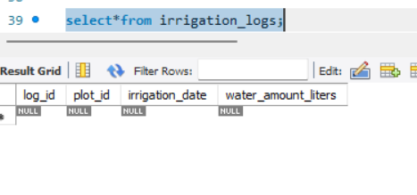

Insert values

INSERT INTO farmers (farmer_id, first_name, last_name, email, hire_date) VALUES
(1, 'John', 'Doe', 'john.doe@agri.com', '2022-01-15'),
(2, 'Jane', 'Smith', 'jane.smith@agri.com', '2022-03-10'),
(3, 'Robert', 'Brown', 'robert.b@agri.com', '2023-05-20');
(104, 'South Valley', 3, 'Wheat', 'Loam');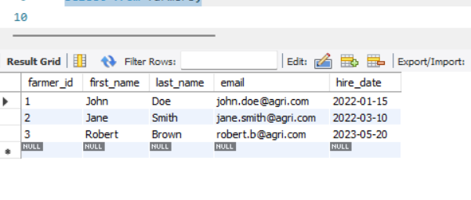

INSERT INTO plots (plot_id, plot_name, farmer_id, crop_type, soil_type) VALUES
(101, 'West Field', 1, 'Wheat', 'Loam'),
(102, 'North Pasture', 1, 'Corn', 'Clay'),
(103, 'East Ridge', 2, 'Soybeans', 'Sand'),
(104, 'South Valley', 3, 'Wheat', 'Loam');

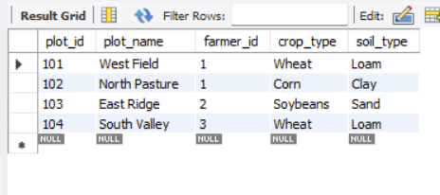

INSERT INTO yields (yield_id, plot_id, harvest_date, yield_kg, weather_condition) VALUES
(1, 101, '2023-06-15', 1200.50, 'Sunny'),
(2, 102, '2023-07-20', 1500.00, 'Mild'),
(3, 103, '2023-08-05', 900.75, 'Rainy'),
(4, 104, '2023-06-18', 1100.00, 'Sunny'),
(5, 101, '2024-06-14', 1250.00, 'Mild');

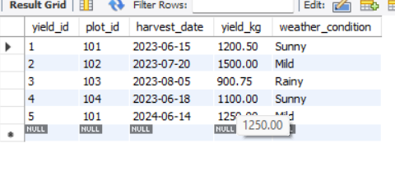

INSERT INTO irrigation_logs (log_id, plot_id, irrigation_date, water_amount_liters) VALUES
(501, 101, '2023-05-01', 5000.00),
(502, 102, '2023-05-15', 7000.00),
(503, 103, '2023-06-01', 3000.00),
(504, 104, '2023-05-05', 4500.00),
(505, 101, '2023-05-20', 4800.00);

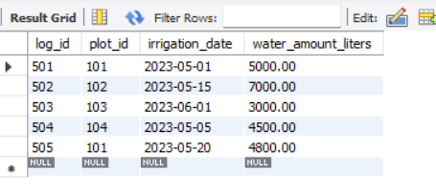

- Productivity & Performance
• Identify the top 3 most productive plots based on average yield per harvest. Show the plot_name, crop_type, and average_yield_kg.
-- Task 1.1: Top 3 most productive plots
SELECT p.plot_name, p.crop_type, AVG(y.yield_kg) AS average_yield_kg
FROM plots p
JOIN yields y ON p.plot_id = y.plot_id
GROUP BY p.plot_name, p.crop_type
ORDER BY average_yield_kg DESC
LIMIT 3;

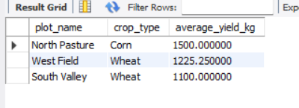

• Calculate the total water consumption for each plot and rank them from highest to lowest. Show plot_name and total_water_liters.
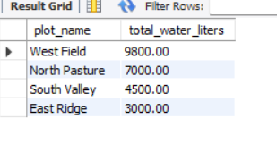

• Determine the average yield for each crop type under different weather conditions. The output should have crop_type, weather_condition, and average_yield_kg.

-- Task 2.1: Yield by crop type and weather condition
SELECT p.crop_type, y.weather_condition, AVG(y.yield_kg) AS average_yield_kg
FROM plots p
JOIN yields y ON p.plot_id = y.plot_id
GROUP BY p.crop_type, y.weather_condition;

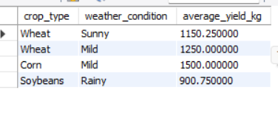

• Find the highest-yielding plot for each soil type. Show the soil_type, plot_name, and highest_yield_kg.

-- Task 2.2: Highest-yielding plot for each soil type
SELECT soil_type, plot_name, yield_kg AS highest_yield_kg
FROM (
SELECT p.soil_type, p.plot_name, y.yield_kg,
ROW_NUMBER() OVER(PARTITION BY p.soil_type ORDER BY y.yield_kg DESC) as rank
FROM plots p
JOIN yields y ON p.plot_id = y.plot_id
) AS ranked_yields
WHERE rank = 1;



• Identify the farmer who manages the plots with the lowest average water consumption. Show the first_name, last_name, and their plots' average_water_liters_per_plot.

-- Task 3.1: Farmer with lowest average water consumption
SELECT f.first_name, f.last_name, AVG(i.water_amount_liters) AS average_water_liters_per_plot
FROM farmers f
JOIN plots p ON f.farmer_id = p.farmer_id
JOIN irrigation_logs i ON p.plot_id = i.plot_id
GROUP BY f.first_name, f.last_name
ORDER BY average_water_liters_per_plot ASC
LIMIT 1;



• Calculate the number of harvests per month for the last 12 months. Show the month and the number of harvests.

-- Task 3.2: Harvests per month for the last 12 months
SELECT DATE_TRUNC('month', harvest_date) AS month, COUNT(yield_id) AS number_of_harvests
FROM yields
WHERE harvest_date >= CURRENT_DATE - INTERVAL '12 months'
GROUP BY month
ORDER BY month DESC;

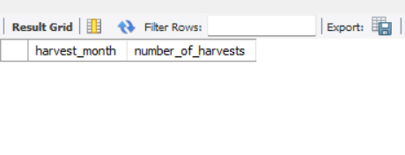

4. Advanced Analysis (Bonus) • Find plots that have a below-average yield for their specific crop type but an above average water consumption compared to all other plots with the same crop. List the plot_name, crop_type, yield_kg, and water_amount_liters.

-- Task 4: Below-average yield and above-average water usage
WITH CropAverages AS (
SELECT p.crop_type,
AVG(y.yield_kg) as avg_yield,
AVG(i.water_amount_liters) as avg_water
FROM plots p
JOIN yields y ON p.plot_id = y.plot_id
JOIN irrigation_logs i ON p.plot_id = i.plot_id
GROUP BY p.crop_type
)
SELECT p.plot_name, p.crop_type, y.yield_kg, i.water_amount_liters
FROM plots p
JOIN yields y ON p.plot_id = y.plot_id
JOIN irrigation_logs i ON p.plot_id = i.plot_id
JOIN CropAverages ca ON p.crop_type = ca.crop_type
WHERE y.yield_kg < ca.avg_yield
AND i.water_amount_liters > ca.avg_water;

